Twtr

Which tongues work best for microblogs?
Mar 31st 2012 | from the print edition
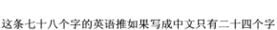
THIS 78-character tweet in English would be only 24 characters long in Chinese:
That makes Chinese ideal for micro-blogs, which typically restrict messages to 140 symbols. Though Twitter, with 140m active users the world's best-known microblogging service, is blocked in China, Sina Weibo, a local variant, has over 250m users. Chinese is so succinct that most messages never reach that limit, says Shuo Tang, who studies social media at Indiana University.
Japanese is concise too: fans of haiku, poems in 17 syllables, can tweet them readily. Though Korean and Arabic require a little more space, tweeters routinely omit syllables in Korean words; written Arabic routinely omits vowels anyway. Arabic tweets mushroomed last year, though thanks to the uprisings across the Middle East rather than any linguistic features. It is now the eighth most-used language on Twitter with over 2m public tweets every day, according to Semiocast, a Paris-based company that analyses social-media trends
Romance tongues, among others, generally tend to be more verbose (see chart). So Spanish and Portuguese, the two most frequent European languages in the Twitterverse after English, have tricks to reduce the number of characters. Brazilians use “abs” for abraços (hugs) and “bjs” for beijos (kisses); Spanish speakers need never use personal pronouns (“I go” is denoted by the verb alone: voy). But informal English is even handier. It allows personal pronouns to be dropped, has no fiddly accents and enjoys a well developed culture of abbreviation. “English is unmatched in its acronyms, such as DoD for department of defence,” says Mohammed al-Basha, a spokesman for the Yemeni government, who tweets in English and Arabic.
Twitter's growth around the world has reduced the proportion of total global tweets in English to 39% from two-thirds in 2009, but polyglot tweeters still often favour the language because of its ubiquity. Many Arabic-speaking revolutionaries used it to get their messages to a larger audience during the Arab spring, sometimes using automatic translation services. Until a recent upgrade, users of Arabic, Farsi and Urdu had trouble using hashtags (words prefixed with the # sign to mark a tweet's subject). Some people use English to avoid censorship. Micro-bloggers on Sina Weibo (where messages containing some characters are automatically blocked) wrote “Bo” in English in order to comment freely about Bo Xilai, a purged party chief.
Though ubiquity and flexibility may give English hegemony, Twitter is also helping smaller and struggling languages. Basque- and Gaelic-speakers tweet to connect with other far-flung speakers. Kevin Scannell, a professor at St Louis University, Missouri, has found 500 languages in use on Twitter and has set up a website to track them. Gamilaraay, an indigenous Australian language, is thought to have only three living speakers. One of them is tweeting—handy for revivalists.

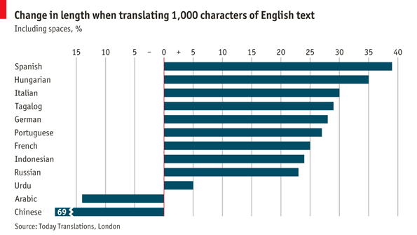

"Twtr: Which Tongues Work Best for Microblogs?" The Economist. N.p., 31 Mar. 2012. Web.

